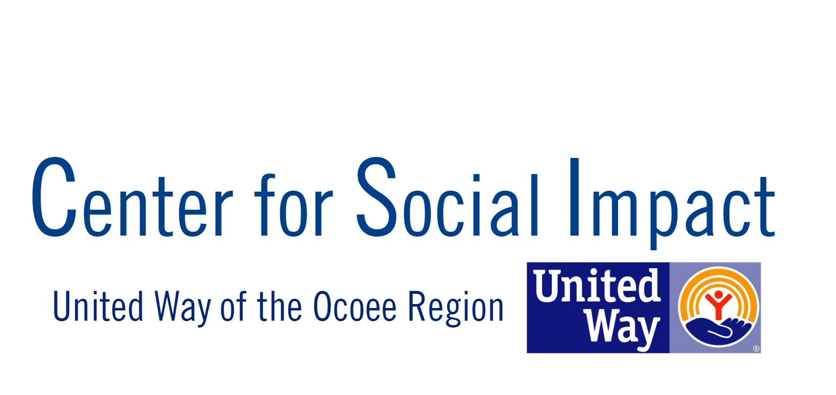
Internship Application
We believe in a region where nonprofits excel at solving complex social problems. Because of this, the Center for Social Impact (CSI) is a catalyst for nonprofits in the Ocoee Region to do just this, with a spirit of collaboration, a commitment to best practices, and a posture of learning. Initiated and led by United Way of the Ocoee Region, twelve nonprofits utilize our collaborative space with opportunities to grow.
During this internship, interns will be able to utilize their strengths and abilities to build the capacity and do behind-the-scenes work with these nonprofits, while also getting nonprofit training, development, and practical experience. With the completion of this program, interns will receive a certificate in Nonprofit Leadership.
Interns will commit to 5-7 hours per week. Two pre-determined hours a week will provide the interns with development opportunities, and the other three (+) hours will be spent working with one of the CSI partners, based on the intern and nonprofit availability. The internship will begin the first week of February 2019 and end mid-April, allotting one week for interns to be out for Spring Break.
Whether you are interested in nonprofits as a career path, strengthening your networking skills or getting hands-on experience, this internship will be beneficial for both you and our Ocoee Region.
How to Apply:
Applications and more information available at www.unitedwayocoee.org/jobs-internships
Applications are due Friday, November 9th, 2019 for the Spring 2019 internship.
Once complete, applications can be emailed to the following:
CSI@unitedwayocoee.org

Applicant Information
Last Name |  |  | First |  |  |  | Date
Street Address |  |  |  |  |  |  |  | Apt/Unit
City |  |  | State |  | Zip
Phone |  |  | Cell Phone
Email address:
Have you ever been convicted of a felony?  Yes  No |  |  |  | If yes please explain:
Do you have a vehicle? Yes  No |  |  |  | If no, do you have a reliable form of transportation? Explain. Yes  No
Do you need this internship for a degree requirement? Yes  No |  |  |  | If so, how many hours are required?
Are you interested in working additional hours (more than 5-7)? |  |  |  | If interested in more hours, how many could you work per week?
How did you hear about our internship program?

Availability
Please check semesters of availability: Fall Spring
 | Monday | Tuesday |  | Wednesday |  | Thursday |  |  | Friday
Please fill in the times you are available:
(9:00am – 5:00pm)

Experience/Education and Skills
Current employment status: Full-time Part-time Not Employed
If currently employed, where?
Current or most recent paid position held:
Are you currently a full-time student?  Yes No |  |  | If yes, please indicate school and concentration:
Level:
Freshmen | Sophomore | Junior | Senior | Graduate student

What skills do you have experience or expertise in? (Marketing, research, writing, volunteer management, event planning, ect) | What areas are you interested learning about?  (Marketing, research, writing, volunteer management, event planning, ect)

Personal Information
Why are you interested in an internship in a nonprofit?

What specific experience would you like to gain through this internship?

Describe your long-term career goals:

This internship will provide opportunities for development and evaluation. Please describe a time that you received feedback and how it was beneficial to you:

Professional References (please provide three)
Name | Relationship and contact info (e-mail and/or phone number)
1.
2.
3.

Resume and work sample
Please attach a copy of your most recent resume as well as a work sample of your area of expertise or interest.

Disclaimer and Signature
I certify that my answers are true and complete to the best of my knowledge. If this application leads to an internship, I understand that false or misleading information in my application may result in my release.
Signature: | Date:

